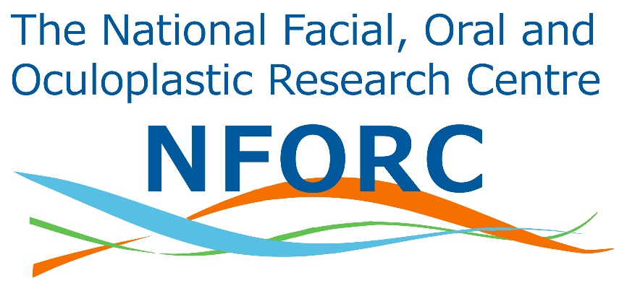
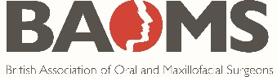

Abstract Submission Form
NFORC and Student Collaborative Research Summit - Wednesday 19th June 2019
If you would like to present your research idea at the Research Summit, please send us a 200-word structured abstract. Please describe the background, rationale, aims and methods and follow the PICO format (if applicable).
Applicant’s Name:
Hospital / Medical or Dental School:
Position (e.g. 4th year, FY1, 6th former):
Email Address:
Phone number:
Title:

Abstract
Background and Aims

Population

Intervention/Observation

Comparator

Outcomes

PICO Guidance Notes
Population - This section should include:
- the inclusion and exclusion population criteria
- how you would recruit patients
- where you would recruit patients

Intervention/Observation – This section should include:
- the intervention of interest
- Or an observation of an area in OMFS

Comparator – This section should include:
- the alternative treatment (e.g. standard care) which could be compared with the intervention

Outcomes – This section should include:
- one primary outcome that you would like to measure. This should be the outcome you consider that is most important.
- secondary outcomes that are also important and appropriate to look at for your research idea
- plan of analysis such as methods of collecting data and statistical analysis

The deadline for submitting the summary is 10th June 2019.
Please submit your abstract by emailing this to nforcresearchsummit@gmail.com
Please do not hesitate to contact us if you have any queries.
Phone: +44 (0)20 8223 8049 (Saving Faces office)
Email: nforcresearchsummit@gmail.com

